LAB 4 ( CIRCUIT DIAGRAMS)
Circuit # 1:
- Measure the current across R1, R2, R3 and Voltage between node 2 and 7.
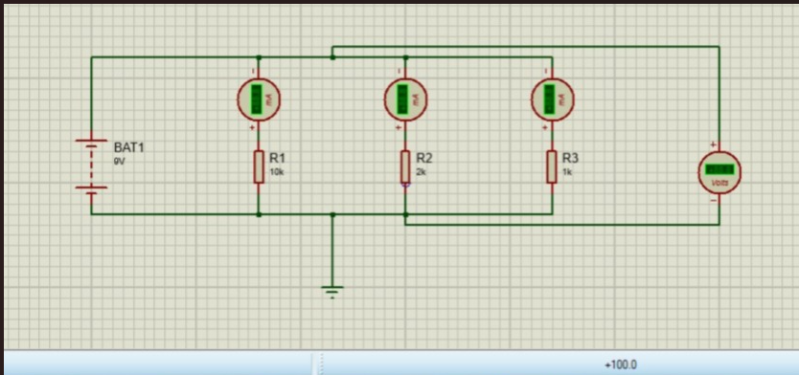

Circuit # 2:
Measure the current across R1, R2, R3 and Voltage between node a and e.
